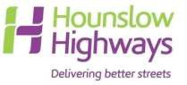

WHITE BAR MARKING APPLICATION FORM
(FOR WHITE LINING IN FRONT OF PRIVATE DRIVEWAYS, CROSSOVERS, GARAGES ETC.)

PLEASE ENSURE THAT YOU CAREFULLY READ THE GUIDANCE NOTES BEFORE COMPLETING AND SUBMITTING THIS APPLICATION FORM

- It is important that the applicant understands that in providing white lines on the highway across a private driveway/dropped kerb for deterring obstructive parking, London Borough of Hounslow (LBH) accepts NO responsibility for the enforcement or any consequences that may arise from the lines. London Borough of Hounslow may in future introduce parking restrictions in your area. In this instance the white line outside your property may be replaced with a yellow line. If you require further information with regards to planned traffic management schemes, please contact LBH on 020 8583 2000. Please note, Hounslow Council will NOT refund any monies if the white line is replaced with a yellow line at a future date.

- The white lines provided are for advisory purposes only and are NOT enforceable by London Borough of Hounslow’s Parking Enforcement contractors.

- A white bar marking (WBM) cannot be provided where waiting restrictions are in force or where other carriageway markings would conflict.

- Payment will only be required after an engineer has visited site to confirm eligibility for a white bar marking and the application has been approved by London Borough of Hounslow Traffic section. The current cost of a white bar marking is £97.00 per affected property. Please do not enclose payment with this application form. Details of the application process and payment can be found on the FAQs page (overleaf).

- Send fully completed application form:

  - Via the ‘Report It’ page at Hounslow Highways Ltd: www.hounslowhighways.org Please scan and attach the application form only and assign “White Bar Marking” under the enquiry description field

  - Or post: White Bar Marking Applications
Hounslow Highways Ltd
Jubilee House
Depot Road
Hounslow
TW3 1SN

FAQS:

Where do I return the application form?
You can return your fully completed application form via post to: White Bar Marking Applications, Jubilee House, Hounslow Highways Ltd, Depot Road, Hounslow TW3 1SN. Or, alternatively scan only the application form (2 pages) and submit online via the Hounslow Highways website at https://fms.hounslowhighways.org/ Unfortunately, we are unable to process applications made verbally over the telephone. If submitting by post, we advise applicants to retain a copy of their application form for their reference. Applications are valid for 3 months after the date of submission. Any applications received after 1st April, will be charged at the new rate.

How long do I have to wait until I hear if my application is successful or not?
There are two stages of the application process. Firstly, your application will be assessed by Hounslow Highways for the eligibility of a WBM. If, upon inspection the location of the required WBM is not allowed, the applicant will be notified within 10 working days after receipt of application. Secondly, should the location be suitable, the application will then be forwarded to the Traffic section at London Borough of Hounslow (LBH) who will assess further suitability taking into account traffic implications, current parking restrictions and lines etc. This will take up to 28 days to carry out. It is LBH who will have final approval. There is no appeal. Please note: The entire WBM application and implementation process can take up to 12 weeks.

I don’t have a vehicle crossover, can I still have a white bar marking?
We are unable to install white bar markings in front of properties where there is not an existing authorised crossover. If you wish to apply for a vehicle crossover (also known as a dropped kerb), please visit https://hounslowhighways.org/roads-footpaths/crossovers/ If you have submitted a dropped kerb application, please allow for installation prior to applying for a white bar marking.

I have a shared crossover with my neighbour. Can I still have a white bar marking?
Please request your neighbour to complete and sign section 4 of the application form stating that they do not object to the installation of the white bar. Please note, your neighbour will also be required to make payment as well.

How much does a white bar marking cost and how do I pay?
The current cost of application and installation of a white bar marking is £97.00 per property affected. Payment is via BACS only. Full payment details will be provided should your application be successful.

When can I expect the white bar markings to be installed following payment?
Please note payment will take 28 days to process once approved by London Borough of Hounslow. Once payment has fully cleared, the white bar marking will be installed within 28 days after that by contractors on behalf of Hounslow Highways Ltd. If, no white bar markings have been installed following this time, please contact Hounslow Highways Ltd at https://fms.hounslowhighways.org/
quoting our reference number. Please ensure that you have allowed for the appropriate duration of time to fully elapse for the works to be implemented before contacting us.

If someone parks in front of my house after I have a white bar marking installed, what can I do?
A white bar marking is not legally enforceable. Hounslow Highways Ltd and London Borough of Hounslow do not accept any responsibility for the enforcement or any consequence that may result from the lines. If a vehicle has parked in front of your property and you have an existing authorised dropped kerb, you may report this to London Borough of Hounslow’s Parking Team on 0208 290 8301 (Option 7) Monday – Friday 0700-2300hrs & Saturday 0900-2300hrs.
Office use only

WHITE BAR MARKING APPLICATION FORM
(FOR WHITE LINING IN FRONT OF PRIVATE DRIVEWAYS, CROSSOVERS, GARAGES ETC.)

Applicant details (PRINT):

Title:
Full Name:
Address: _____________________________________________________________________
Town:
Postcode:
Email:
Tel. No.:

- Additional Information: Please explain the circumstances that have led you to make this application, e.g. repeated vehicle obstruction of your private driveway, crossover or garage etc.

Please provide below a drawing clearly indicating the position of your property in relation to the driveway or dropped kerb. This is required in case the location of the driveway/dropped kerb is not obvious to our engineer upon site inspection or the location of where the white bar marking is required is not obvious.

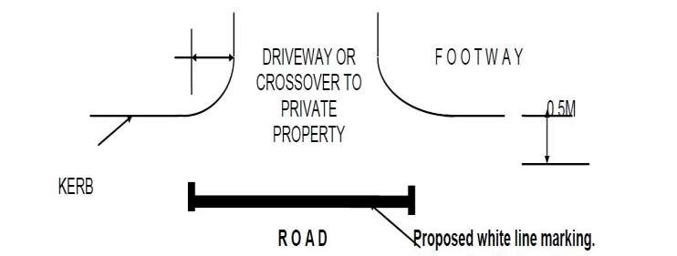
The white bar marking must extend one metre beyond the limit of the driveway or crossover.
INSERT DETAILED DRAWING HERE:
- Are there currently any road markings across or close to your access or driveway? (i.e. yellow lines, traffic arrows) If yes - please clearly indicate on your drawing above.

YES NO

Is your access or driveway shared with your neighbour?

YES NO

If YES, please confirm that your neighbour is in full accordance with you regarding the proposed white line marking and payment of associated costs.

I confirm that my neighbour is in full agreement for installation of a white bar marking.

SIGNATURE OF NEIGHBOUR: _ _____________

NAME OF NEIGHBOUR (PRINT): _____________

ADDRESS OF NEIGHBOUR:_______________________________________________

DATE:___________________________CONTACT NO.__________________________

I confirm that there is an existing dropped kerb in front of the property that I am applying for a white bar marking to be installed. I understand that upon my application, if no existing authorised dropped kerb is found in front of the property, my application will be refused.

Signature: Date: _

